|  |
| --- |
|  |

Research Project Initiation – SIT723

|  |  |
| --- | --- |
| **Student Name:** | Satvik Sharma |
| **Supervisors’ Names:** | Maia Angelova |
| **Project Title:** | Financial time series analysis with Machine Learning |
| **Student Details** | |
| **Course:** | Bachelor of Software Engineering |
| **Research Experience:** | I have worked on literature reviews for the project and have very basic experience in research |
| **Technical Skills:** | I have experience in working in a lot of languages, including C, C++, python, Java et cetera along with management skills including working in a team or working individually. |
| **Research Units related Information** | |
| **SIT723 Target Grade:** | Distinction |
| **Expectations from the unit:** | I believe this unit will help in understanding how research is done on a particular topic and might be helpful to me in future, while doing my PhD or working in a corporate |
| **Will you continue to Research Project B (SIT724)?** | Yes, I will continue to Research Project B. That will be the conclusion to the research which I started in the Research Project A |

# Project Requirements

## Research Integrity Training

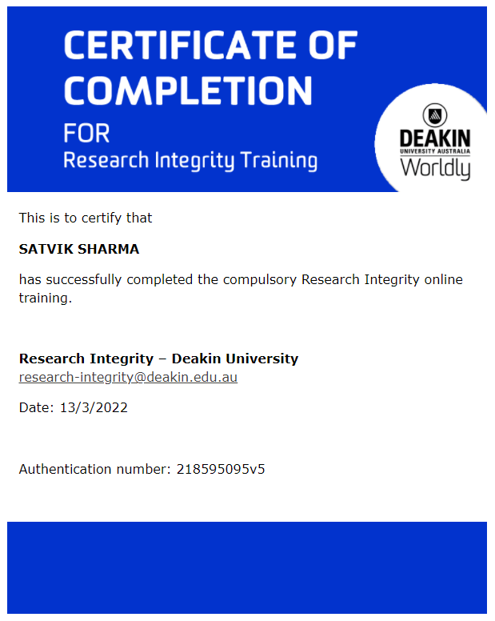

## Deakin ethics quiz attempt

## 

# Project Management Requirements

## Overleaf Repository

For editing

<https://www.overleaf.com/7593645898fsydrtqsdgzb>

For viewing

<https://www.overleaf.com/read/frvfvmnnrstb>

## Project Resources Repository

Team project link

[*https://deakin365.sharepoint.com/:f:/r/sites/SIT723-FinancialTimeSeriesAnalysiswithMachineLearning/Shared%20Documents/General/Satvik%20Sharma(218595095)?csf=1&web=1&e=Aqw8K8*](https://deakin365.sharepoint.com/:f:/r/sites/SIT723-FinancialTimeSeriesAnalysiswithMachineLearning/Shared%20Documents/General/Satvik%20Sharma(218595095)?csf=1&web=1&e=Aqw8K8)

*GitHub repository*

[*https://github.com/satviksharmase/Financial-Time-Series-Analysis-with-Machine-Learning*](https://github.com/satviksharmase/Financial-Time-Series-Analysis-with-Machine-Learning)

*Google docs*

[*https://docs.google.com/document/d/1XNmV4JUud_WbqAhd9UM-C-C1deOChgPAUOA6f_YROIY/edit?usp=sharing*](https://docs.google.com/document/d/1XNmV4JUud_WbqAhd9UM-C-C1deOChgPAUOA6f_YROIY/edit?usp=sharing)

## Worklog

Worklog repository link

<https://docs.google.com/spreadsheets/d/1g7c1B_oiS9Mnx4aI0rkOPT0hZAtqWxoVgN3WrK0hru8/edit?usp=sharing>

## Project Tentative Plan

[Share the tentative plan using the table below for your project here.]

*Each research project is different; however, you need to reach certain milestones for passing this unit. These include completing your literature review, research design, (minimum-viable) artefact development and evaluation plan. Finally, you also need to complete your research report.*

|  |  |  |
| --- | --- | --- |
| Module | Suggested Deadline | Agreed Deadline |
| Literature Review Draft | End of Week 3 | End of week 3 |
| Literature Review | End of Week 4 | End of week 4 |
| Research Design | End of Week 6 | End of week 6 |
| Development Sprint and Evaluation Results | End of Week 9 | End of week 9 |
| Research Report Draft | End of Week 10 | End of week 10 |
| Final Report and Learning Summary Report | End of Week 12 | End of week 12 |